I. For each statement below, Explain Why it is True or False (2 points each, 10 total)

- Program execution consists of repeating the process of instruction fetch and instruction execution.
- One drawback of sign-and-magnitude representation is that there are two representations of 0.
- Both sign-and-magnitude representation and twos complement representation use the most significant bit as a sign bit.
- Addition and subtraction can be performed on numbers in two’s complement notation by treating them as unsigned integers.
- Overflow only happens in addition operation of two large numbers.

II. Multiple Choices – Choose ONLY 1 Answer (2 points each, 20 points total)

- Which of the following sentences about 8-bit two’s complement is correct?
- The most significant bit has a weight of −2⁶
- The representation range is −128 to +127
- The representation n range is −127 to +128
- To calculate −x from x, we flip all the bits and subtract 1

- The processing required for a single instruction is called a(n) __________ cycle.
A. instruction B. fetch
C. execute D. packet

- In ________ representation the rule for forming the negation of an integer is to invert the sign bit.
A. two’s complement B. sign-and-magnitude
C. biased D. one’s complement

- ________ is when the result may be larger than can be held in the word size being used.
A. Underflow B. Arithmetic shift
C. Overflow D. Partial product

- Positive numbers less than 2⁻¹⁸³ (i.e. 10⁻⁵⁵ in the book) could cause ________.
A. negative underflow B. negative overflow
C. positive underflow D. positive overflow

- During the _________ the Little Man goes to the mailbox address specified in the instruction he previously fetched.
A. execute portion B. fetch portion
C. instruction cycle D. clock cycle

- The __________ interprets the instructions in memory and causes them to be executed.
A. main memory B. I/O
C. control unit D. arithmetic and logic unit

- Which of the following sentences about IEEE 754 single precision floating point numbers is correct?
- The exponent is represented in two’s complement
- 0000 0001₁₆ is the largest denormalized number
- 8000 0000₁₆ represents the number −0
- The number 1.111₁₀ × 10² can be represented with no precision loss

- The von Neumann architecture has which of the following features?
- Programs cannot be modified while the processor is running
- Data and programs share the same address space
- Each machine instruction contains the address of the next instruction
- Programs have to be written in assembly language

- The binary string 1011 1000 1111 is equivalent to __________.
A. DE1₁₆ B. C78₁₆
C. FF64₁₆ D. B8F₁₆

III. Short Answers (4 points each, 28 points total)

- Explain the difference between lossless and lossy data compression. Which type normally provides a smaller file? What is ‘‘lost’’ in lossy audio data compression? Under what circumstances is it impossible to use lossy data compression?

- Explain how multiplication was implemented in binary format in computers. Use an example such as 157 * 19 to explain the multiplication step by step.

- Carefully describe the advantages and disadvantages of master-slave multiprocessing and symmetric multiprocessing. Which would you select for fault-tolerant computing? Why?

- Give an example that shows the disadvantage of using a sign-and-magnitude format for manipulating signed integers.

- What is a stack? Explain how a stack works. Use a diagram or example to show how PUSH and POP instructions are used in stack instructions for subroutines.

- Why are there two different registers (MAR and MDR) associated with memory? What are the equivalents in the Little Man Computer?

- Most modern computers use superscalar. Explain the performance benefit obtained from superscalar.

IV. 2’s Complement (6 points each, 24 points total)

Using 4-bit two’s complement numbers for questions (a) & (b), show how to represent the following operations and their results. If operation cannot be done, explain why.

- 5 - 8

- 12 - 5

- Let the decimal numbers A=66, B= -65, give their 8-bit 2’s complement representation

- Compute A-B in 2’s complement, and explain the steps of your solution. If there is any problem in finding the solution, explain as well.

V. Little Man Computer (6 points each, 18 points total)

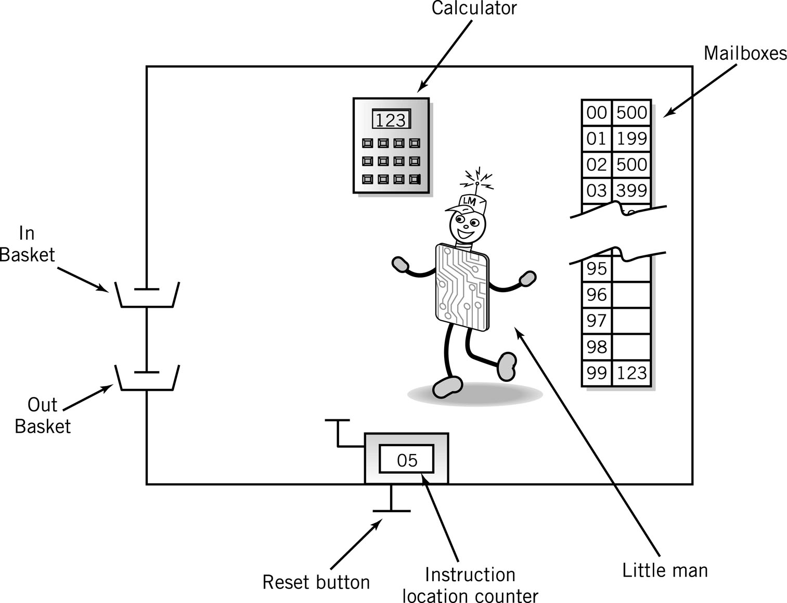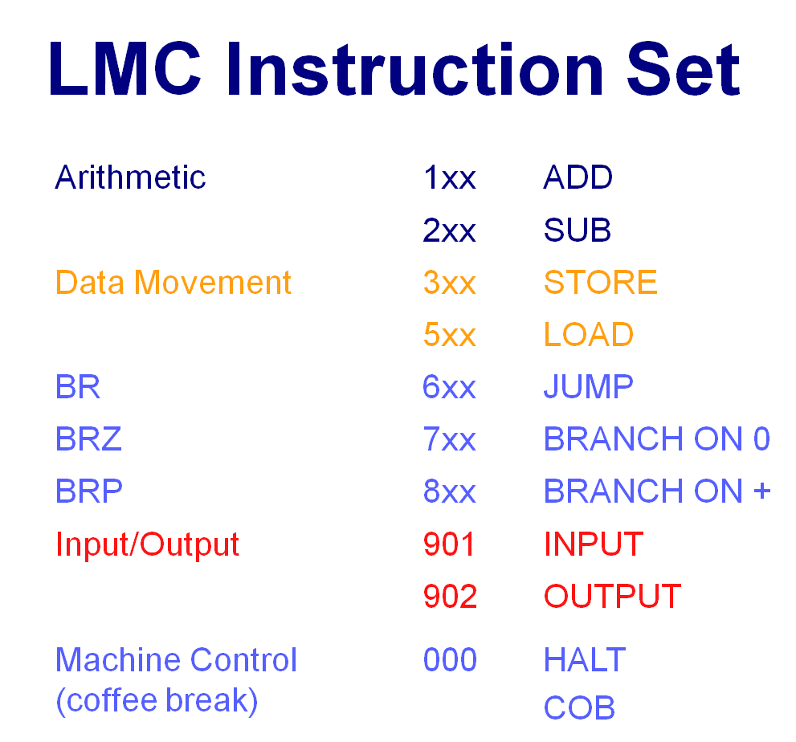

Using the Little Man Computer and Instruction Set, answer the following questions:

- Write a program that asks for 3 numbers (say, A, B, and C) and then calculate -A-B-C. Output the result

- Write a program which outputs the numbers 9,8,7,6,5,4,3,2,1,0 then stops.

- The following program tries to find the positive difference between two input numbers, read the code to check whether there are some errors and correct them (without using more DAT mail boxes, that is, data location is only the cell 99).
00 IN 901
01 STO 99 399
02 IN 901
03 SUB 99 299
04 BRP 06 806
05 ADD 99 199
06 OUT 902
07 COB 000
… … …
99 DAT 00 000

